LAB 7

Polynomial Interpolation

Assignment:
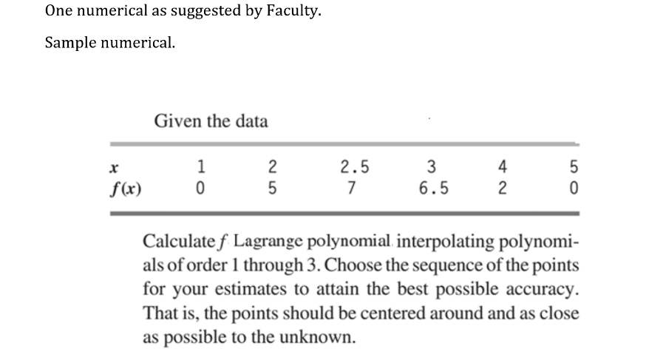

Hand Calculation:
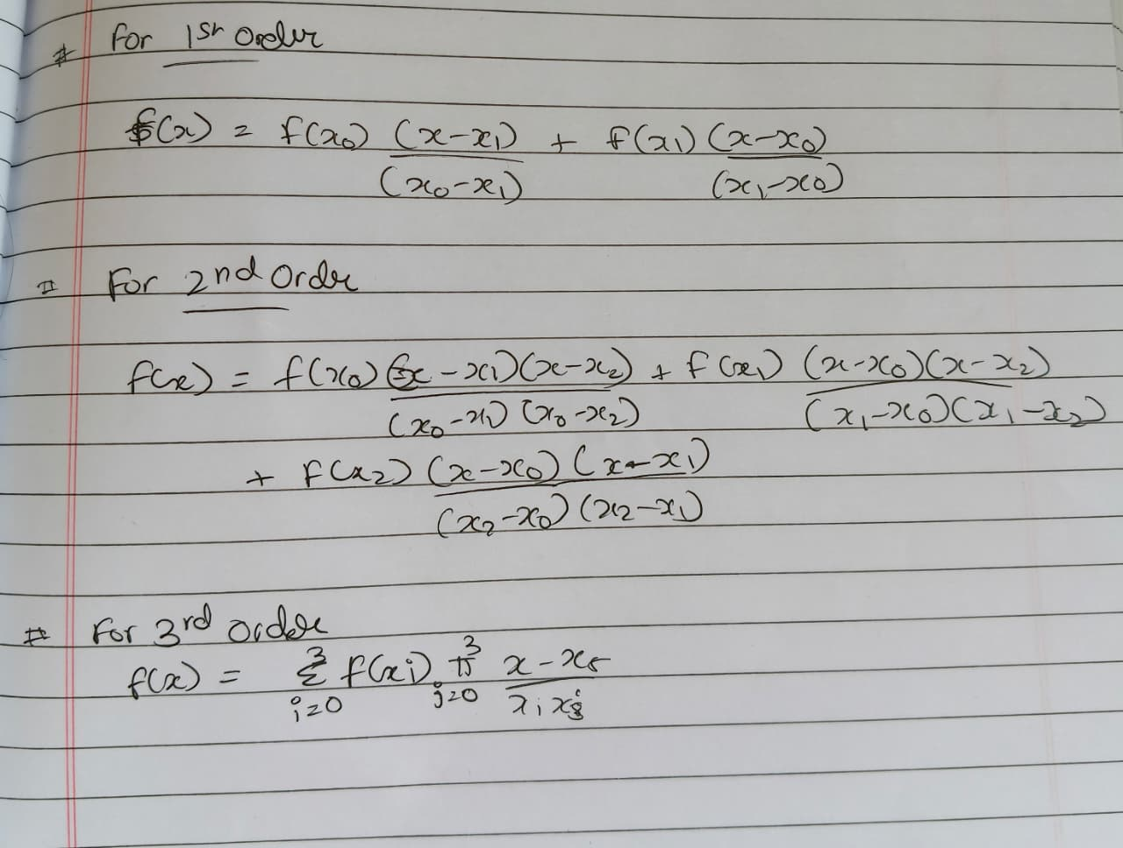
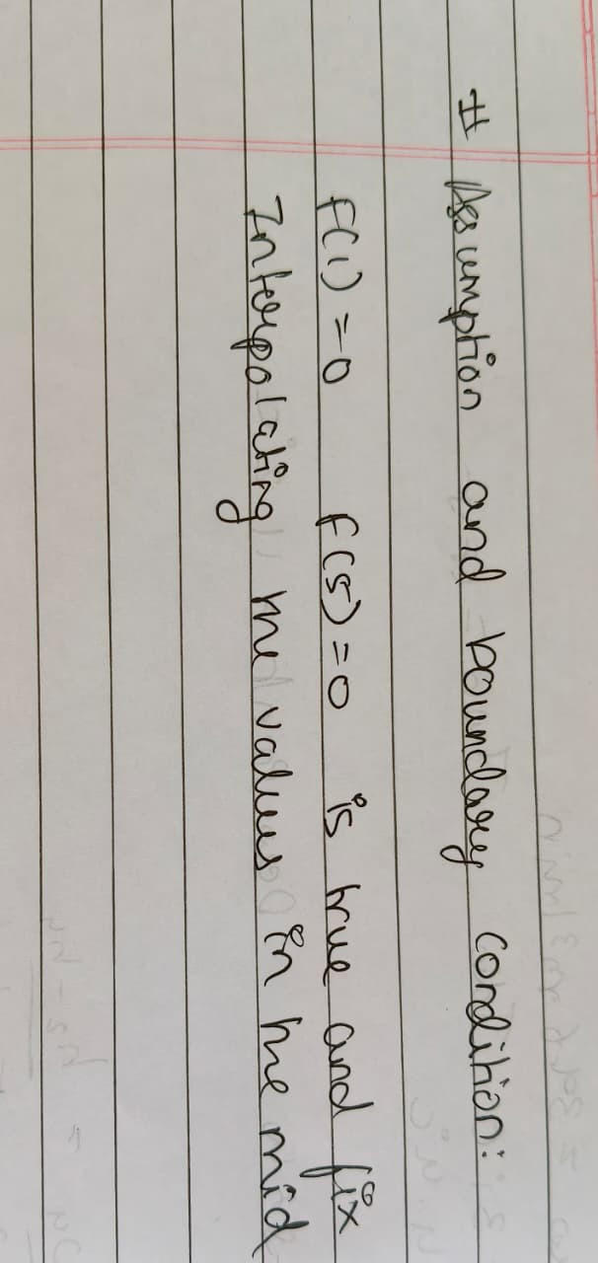

Matlab Code
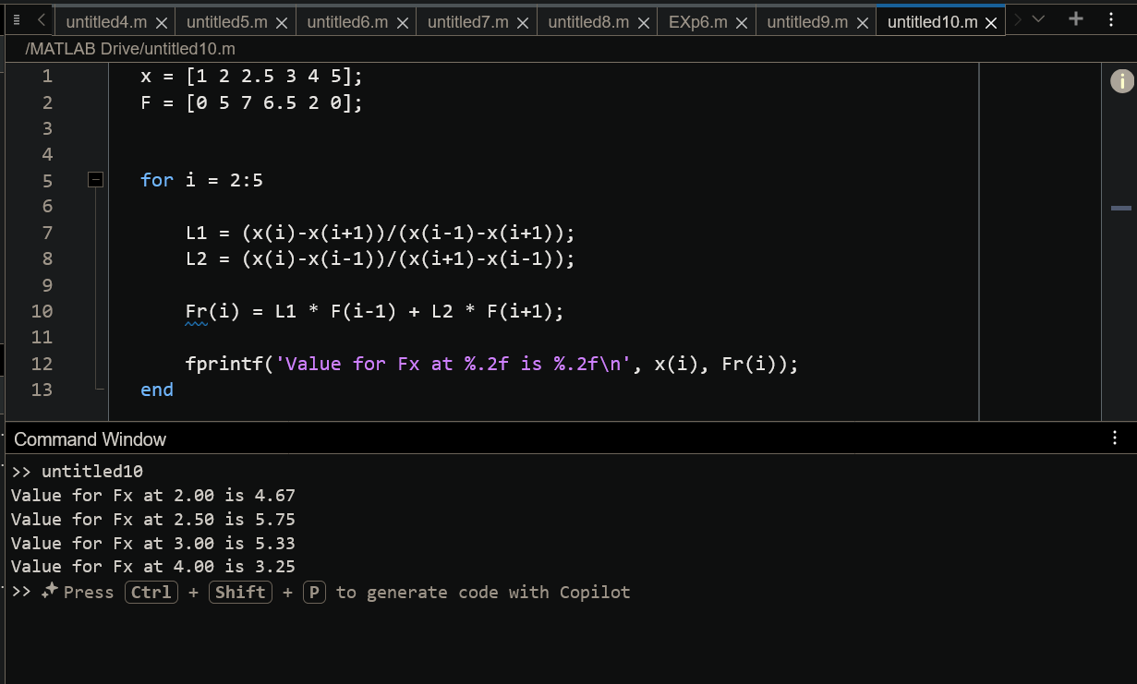
Figure 1 Matlab code for first order interpolation
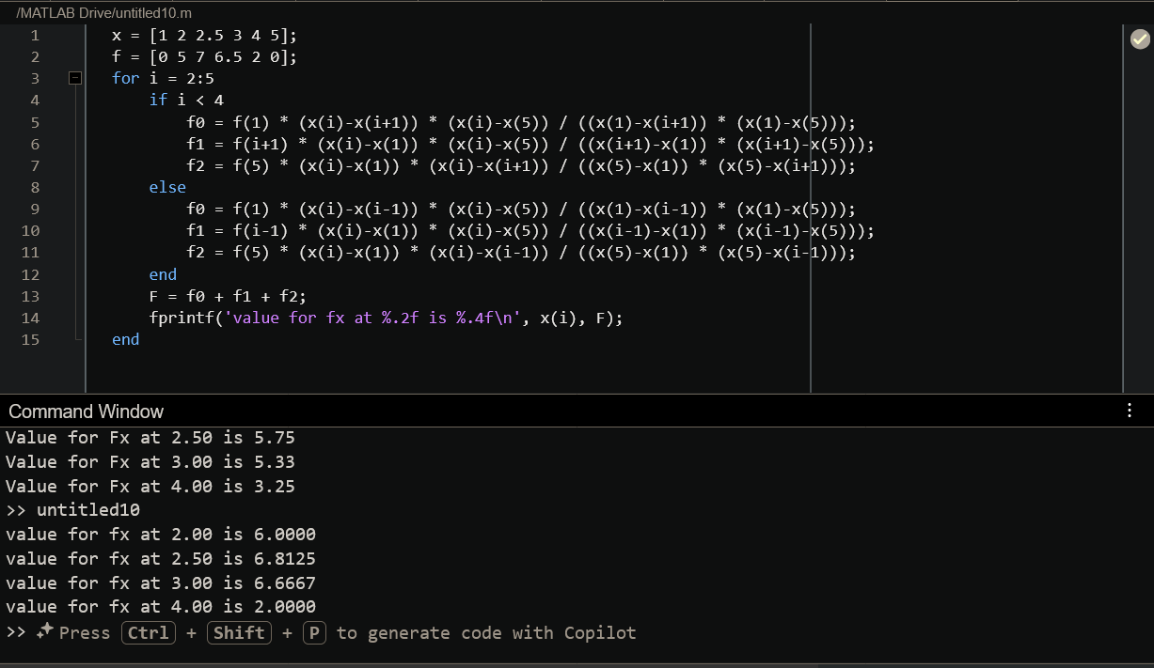
Figure 2 Matlab code for second order interpolation

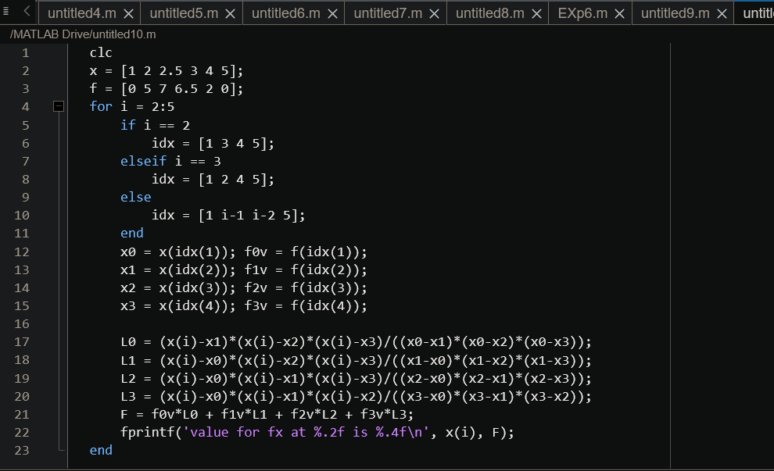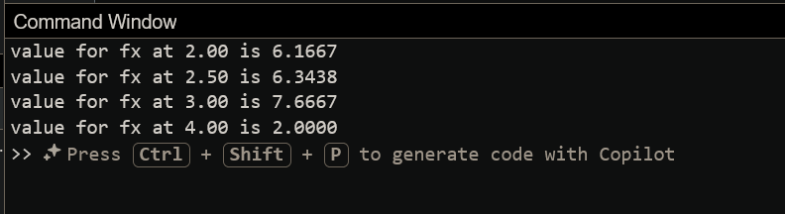
Figure 3 Matlab code for third order interpolation
Result
The function values were estimated using Lagrange interpolation of first, second, and third order. It is observed that as the order of the polynomial increases, the approximation generally improves because more data points are considered. However, accuracy also depends on the proper selection of points. Interpolations using points closer and centered around the required value give better results. Hence, higher-order interpolation does not always guarantee better accuracy unless appropriate points are chosen.

